ASSET MANAGEMENT IN INDUSTRY 4.0

Asset management continues to remain the main concern of businesses across the world . Why? **Assets sustain businesses.**



Highlights:

* What is asset management?
* Types of asset management
* What are the best practices for effective asset management?
* What is predictive maintenance and how does it benefit organizations?
* Connecting the dots between Asset Management and Industry 4.0

What is asset management?

Every other day we hear about a company shutting down or moving to some other country due to financial issues . What do you think gives rise to such a situation . Well the answer to this question is asset management.

Asset management is the term used for the process of planning , maintaining , operating and selling organizational assets in a cost-effective manner. This process enhances the delivery potential of assets and minimizes the costs as well as risks.

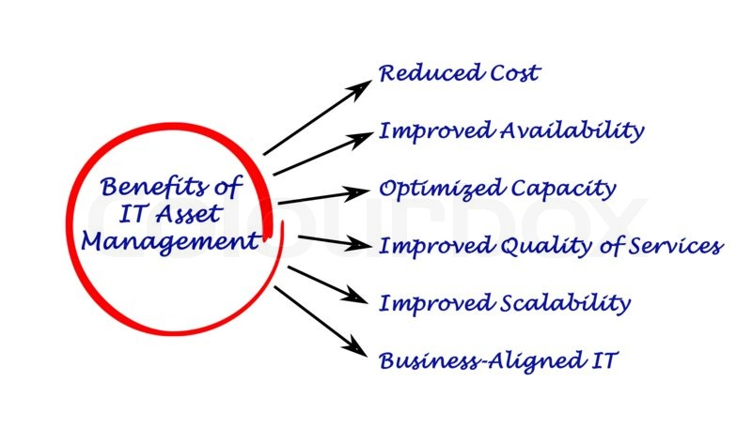

What are the types of Asset Managements?

* Physical asset management : includes the processes regarding handing things such as fixed asset management, inventory management , infrastructure and public asset management.
* Financial asset management: includes process of managing procurement, keeping in check the budget and handling cash, bonds and stocks.
* Contractual compliance : includes streamlining of processes such as digital and IT asset management , contractual maintenance and that of intangible assets.

Steps to Effective Asset Management

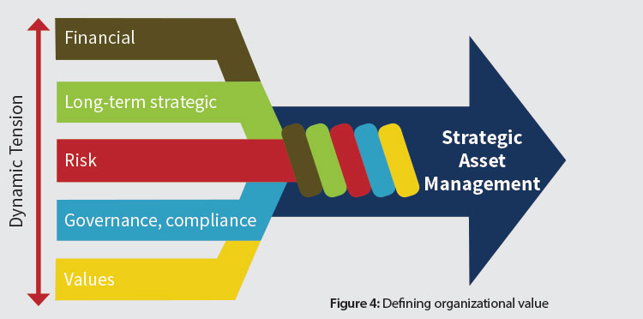

* Strategy and Planning :

Devising a strategy for meeting the target objectives and appropriate planning is a major factor that makes up for an effective asset management. The organization’s asset management activities should be in alignment with the overarching facility objectives , in order to provide clarity to asset management priorities.

* Asset Management Decision Making :

Decision making plays a vital role in governing effective asset management. Data should be collected in an organized manner and must be easily comprehensible so as to aid in effective management of data and maximize the value realized over the life its asset portfolio.

* Asset Information :

For implementation of an effective asset management, it is essential that the quality of information received to carry out decision -making process is accurate and up-to-date.

* Risk and Review:

The identification , analysis and management of risk is an integral aspect of good asset management strategies . The best -performing operations understand the importance of risk management and relentlessly work on improvements .

**Predictive Maintenance in Asset Management**

If businesses want their operations to function smoothly and increase the life cycle of their assets , asset maintenance is a must.

To improve the competitiveness of your business it is important to find ways to increase Return on Assets(ROA) and base the maintenance decisions on solid facts and collect data that can strengthen your planning and effectively maintain your assets.

Three types of maintenance:

|  |  |  |  |
| --- | --- | --- | --- |
| Property | Predictive | Reactive | Preventive |
| * **Time of activity** | As and when required | After breakdown occurs | At predefined intervals |
| * **Benefits** | * Improved analytics * Least risk of breakdown * Prevents unnecessary maintenance procedures * Balances labor and inventory | * Ideal for low-priority equipment * Maximum utilization and production value from asset | * Lower maintenance * Costs effective * Reduces unplanned downtime |
| * **Challenges** | * Complex system * Increased upfront infrastructure setup | * Unplanned downtime may occur * Expensive to maintain * Potential risk to the assets | * Increased planned downtime * Need for inventory management and spare pats. |

**Predictive maintenance**

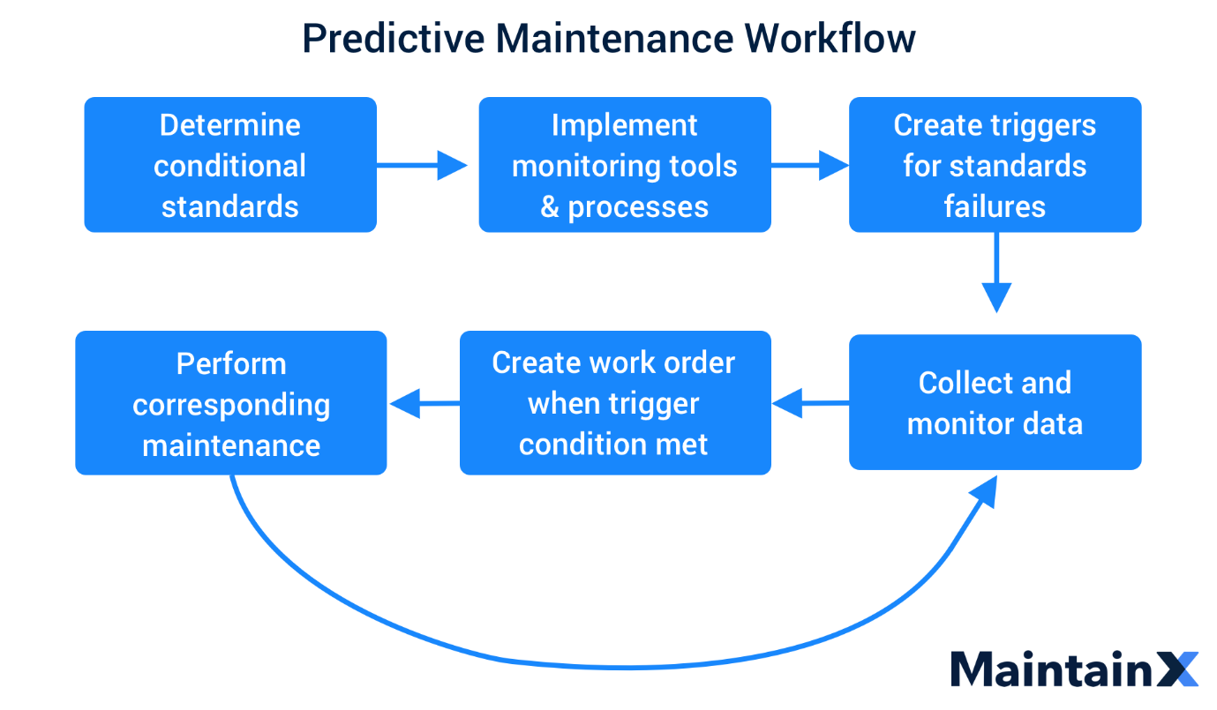

Predictive maintenance refers to the use of data -driven proactive maintenance to detect anomalies in your operation and defects in your equipment and helps in predicting when maintenance should be performed.

Predictive maintenance evaluates the current condition of the equipment by carrying out periodic equipment condition assessment . More often than not predictive maintenance is performed while the equipment is under normal operation to minimize disturbing of everyday operations

Pros of predictive maintenance:

* Beneficial from Health ,safety and Environmental point of view as asset maintenance is being optimized
* Lesser materials needed and few risk- prone operations involved.
* Improved efficiency and reliability to the clients , investors and stakeholders because of less shutdowns.
* Saves time of maintenance personnels by concise and clear management of information , thereby allowing them to concentrate on other relevant asset management issues.

Asset Management and Industry 4.0

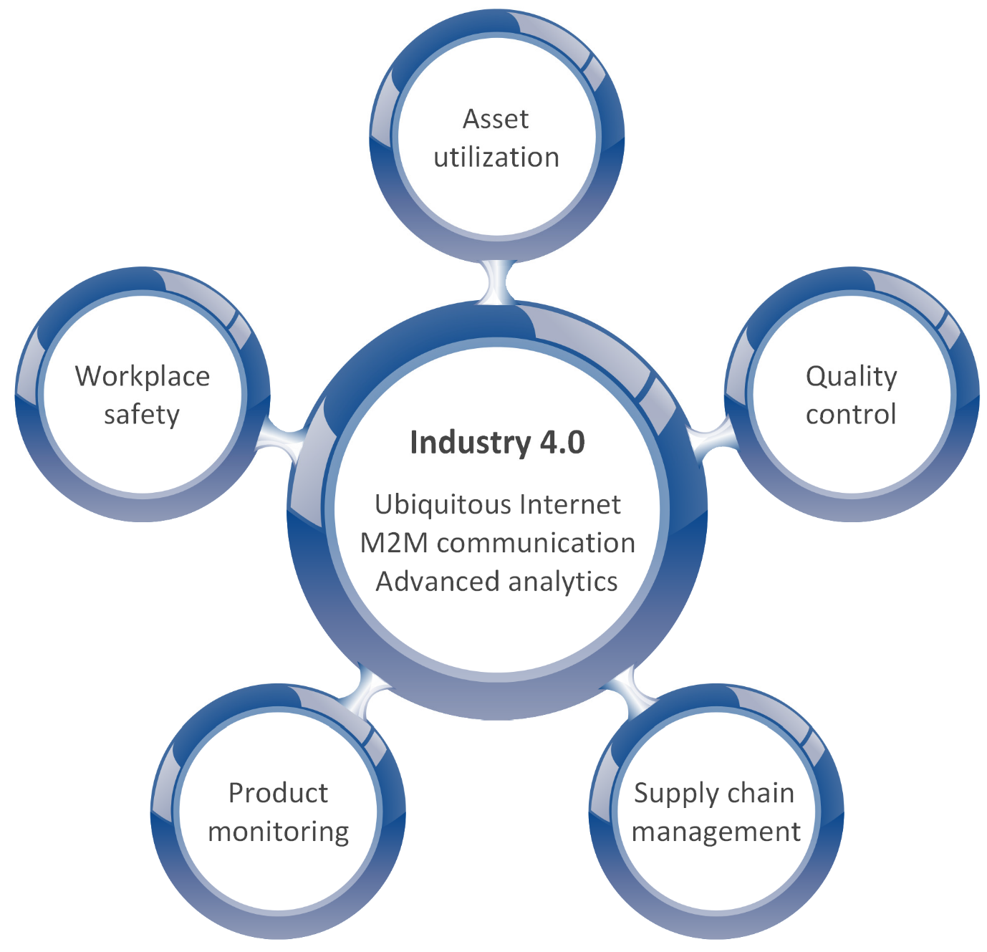

Asset management has an interesting link to the fourth Industrial revolution. Companies are taking to the smart predictive maintenance , instead of reactive or preventive ones.

Think of it this way , how beneficial it would be to manage your assets with the technology of the future , think about the flexibility and scalability the Industry 4.0 technologies would impart to your assets.

Having an overview about how assets depend on each other , the relationship between them will give an insight on the impact of downtime , delays on spares and power outrages.

Now , this is where Industry 4.0 comes into picture .

* With the modern day technologies of Industry 4.0 , one can not only understand the dependencies and connections between one’s assets but also gain a profound understanding on the performance , effects and faults on a much broader and detailed scale.
* Installing IoT sensors and enabling of data connectivity implies that companies can conveniently predict machine interruptions and be more flexible with machine failures and changeovers.
* Assets that are equipped with machine learning algorithms can predict outcomes for future scenarios.
* Equipment fixed with smart sensors and connected to a cloud based IoT platform will enable companies to understand a great variety of characteristics of their assets , thus helping them to detect inefficiencies and work towards improving their asset management.

Conclusion

The pace of technology can be overwhelming for organizations but no matter where you stand on the Industry 4.0 journey , consistent strategic planning and implementation can help them to catch up with the pace and help them generate the best return on their assets and investments.